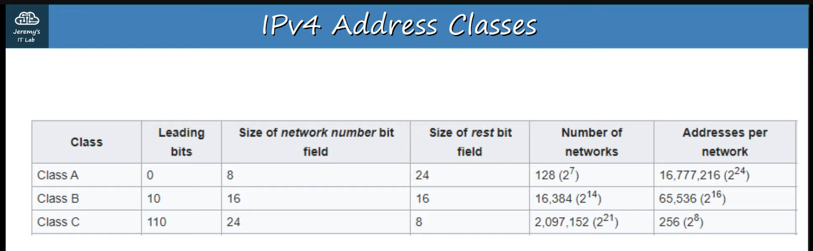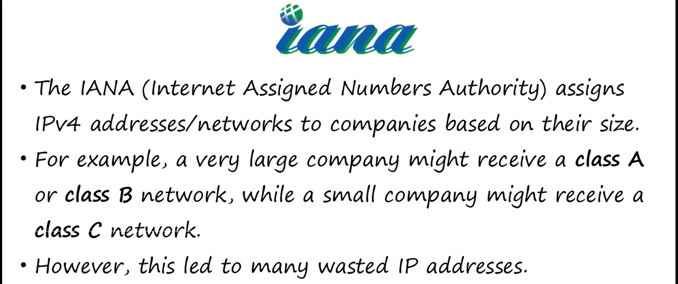

**This system to assign the IP address is called “classful-addressing”, in this system, many IP addresses are wasted, e.g., ↓**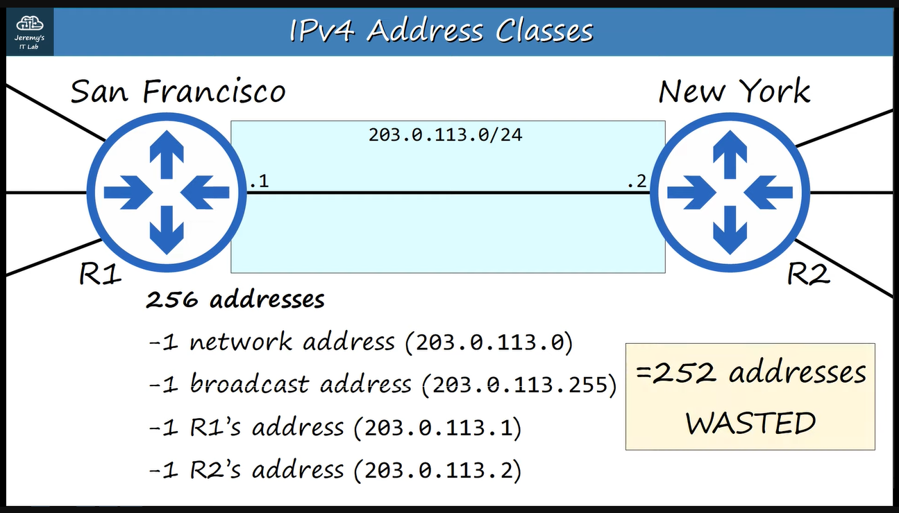

**Therefore, another system called “CIDR” was introduced by the “IETF” in 1993.**

**CIDR 🡪 Classless Inter-Domain Routing**

**IETF 🡪 Internet Engineering Task Force** 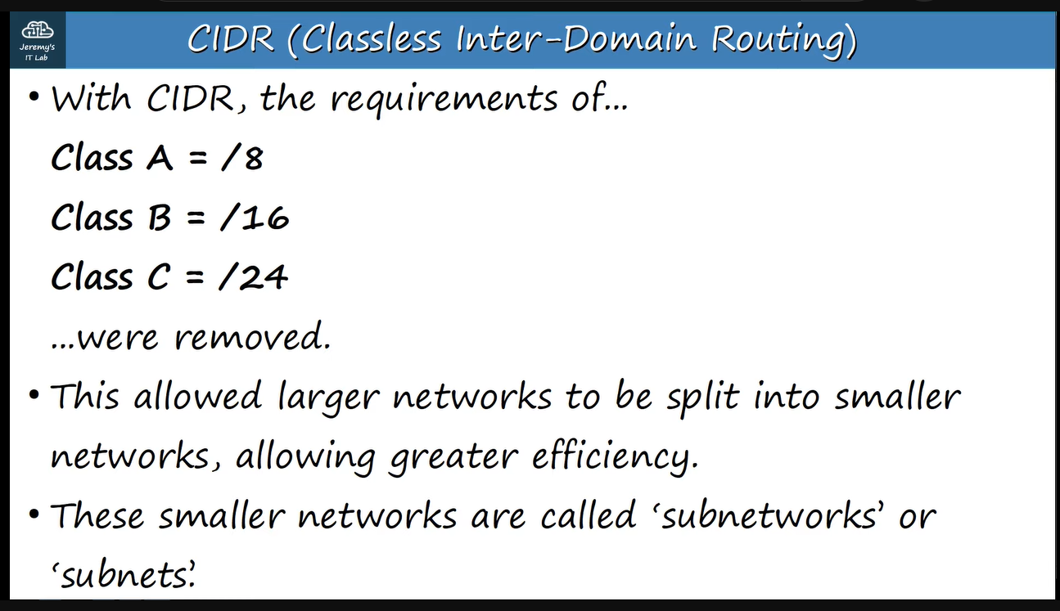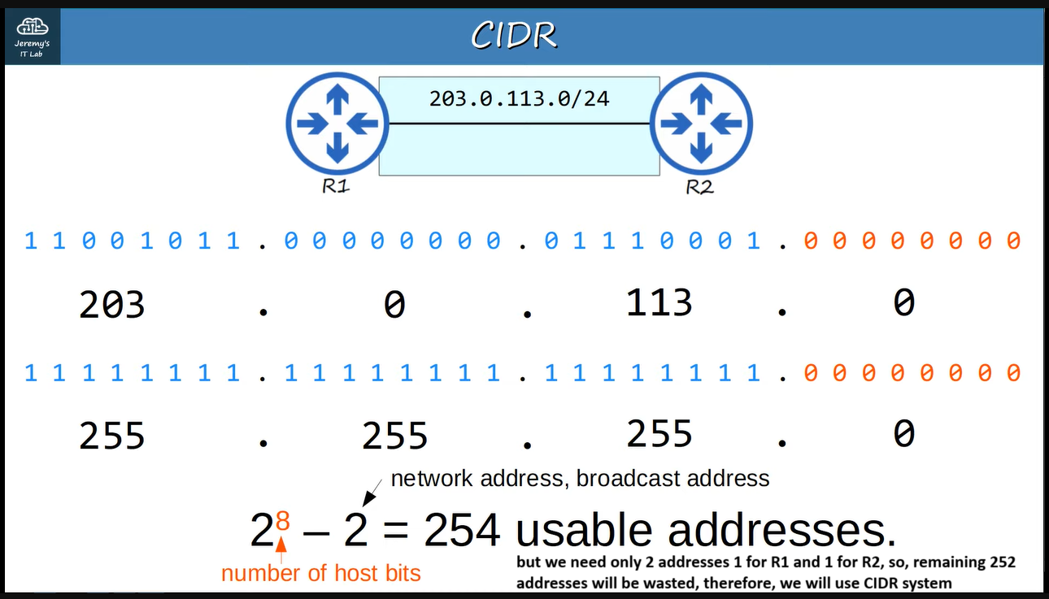

**Now we will se some examples of CIDR adressing**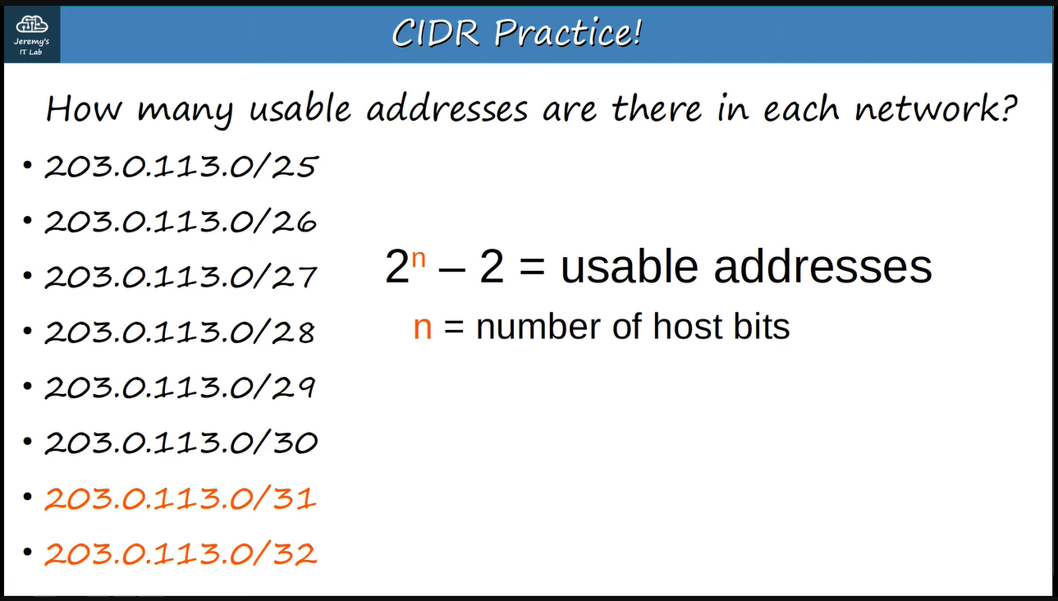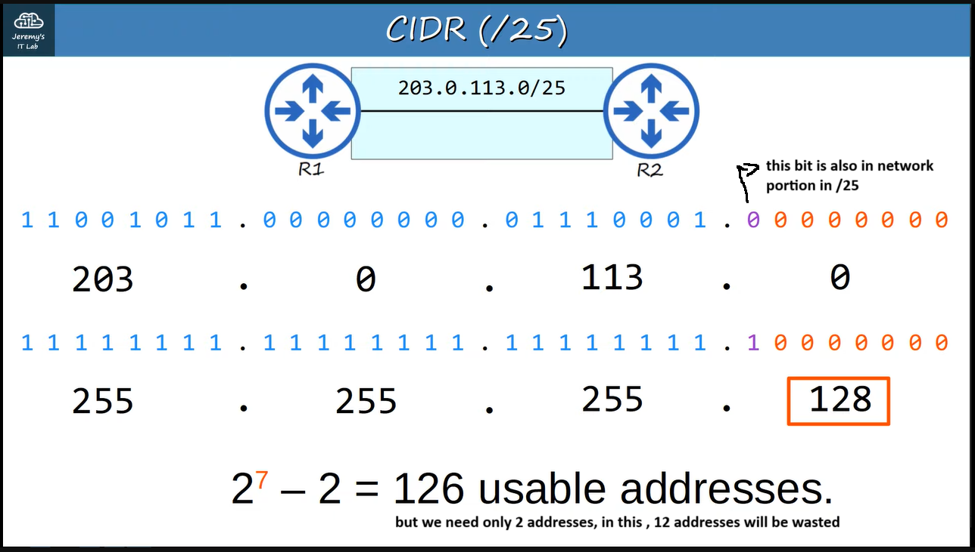

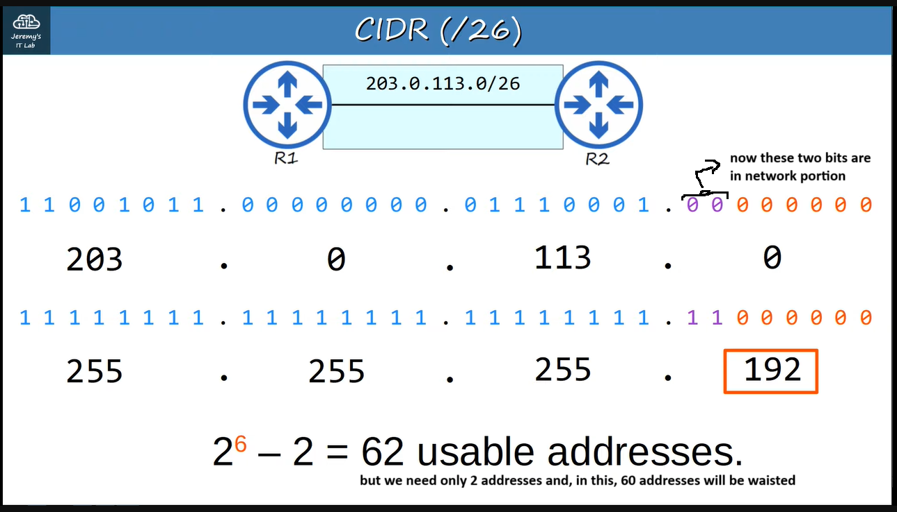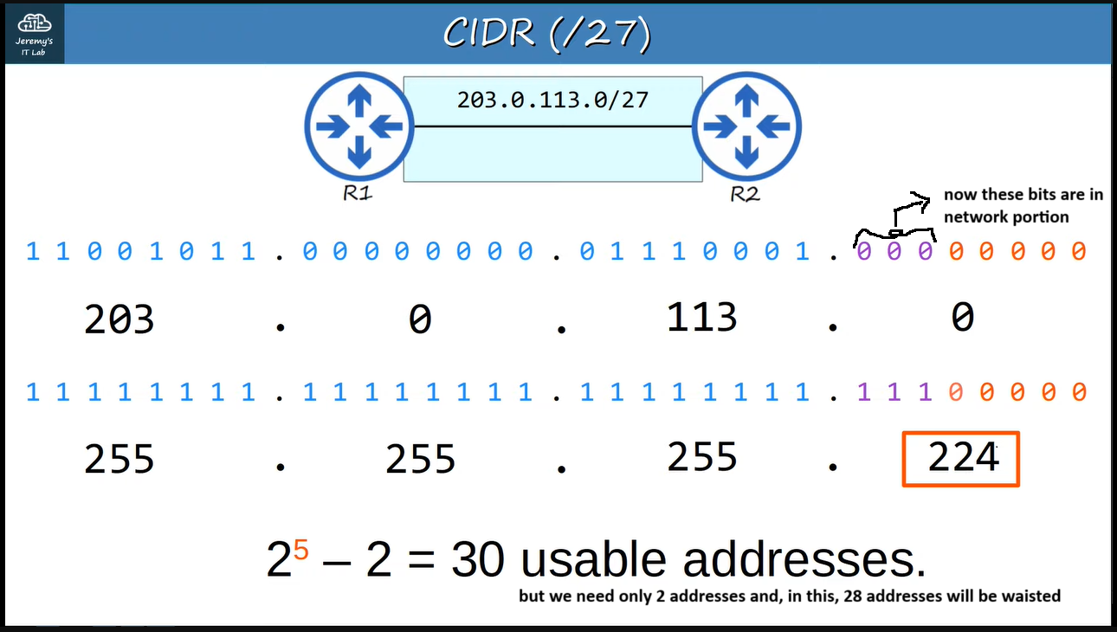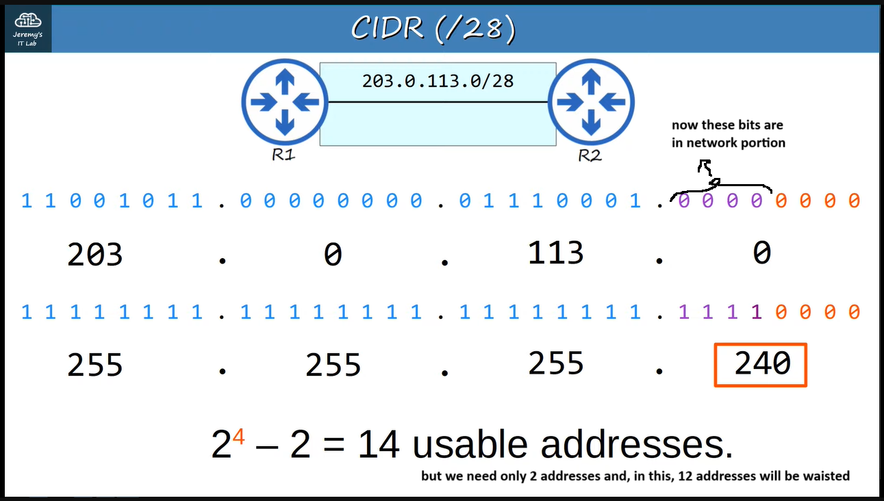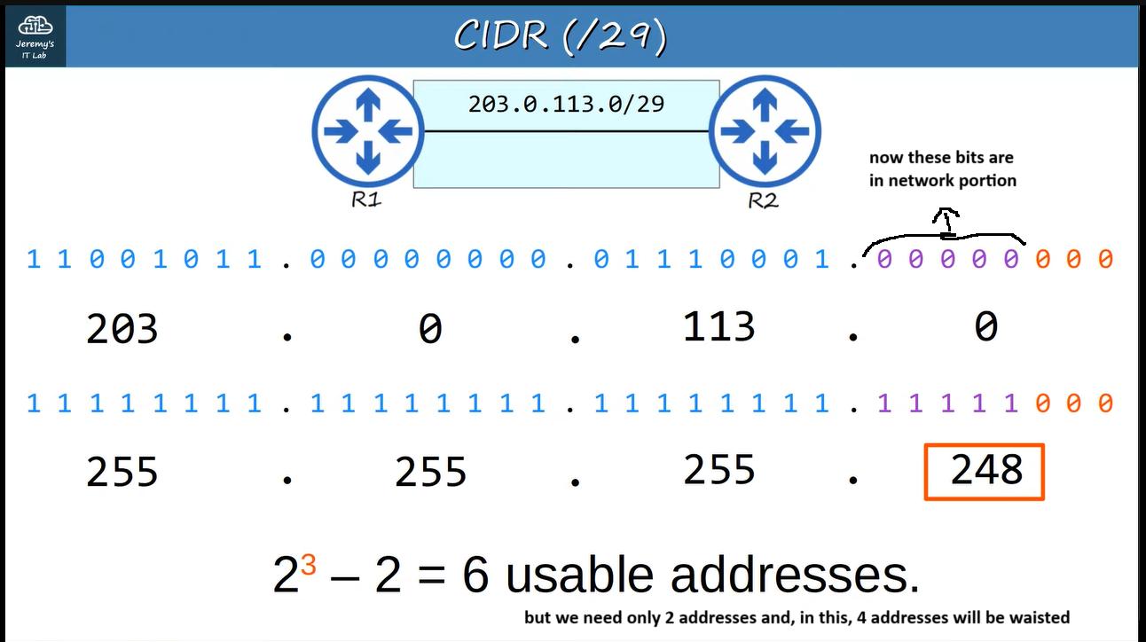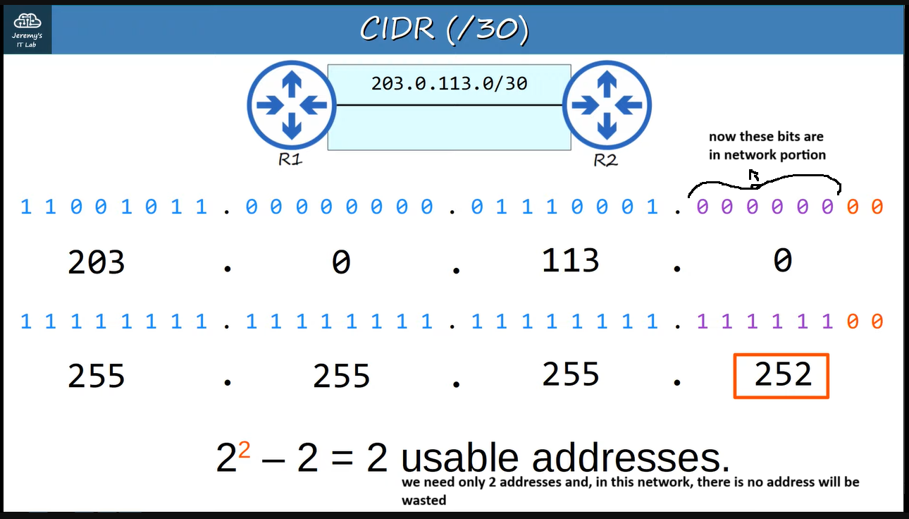

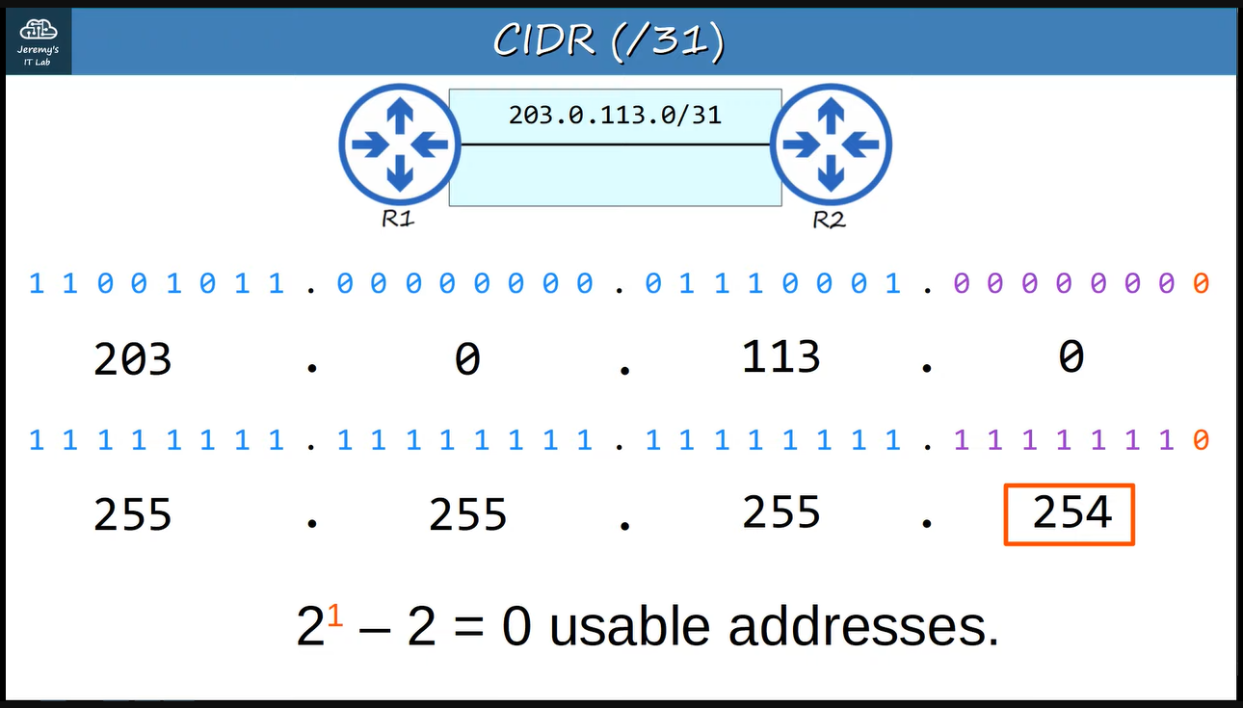

**On using /31, there is no usable address but we use it for point-to-point connection between routers because they do not need network address and broadcast address ↓**

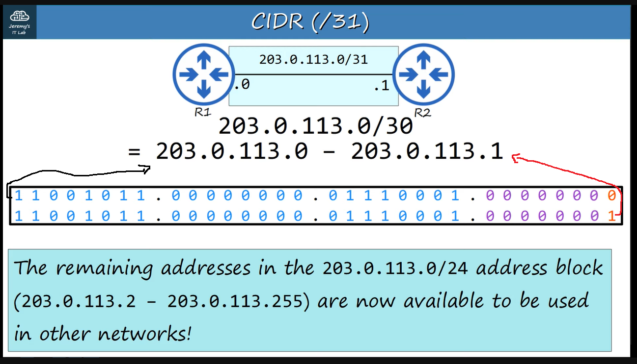

**The cisco router warns when we configure it ↓**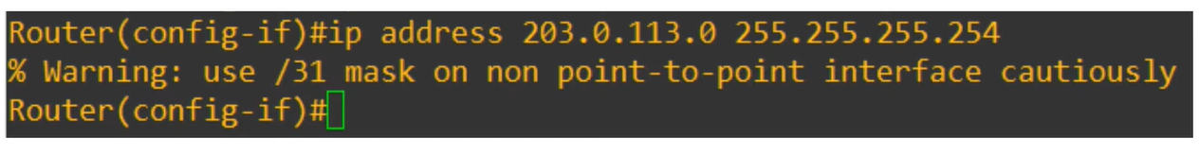

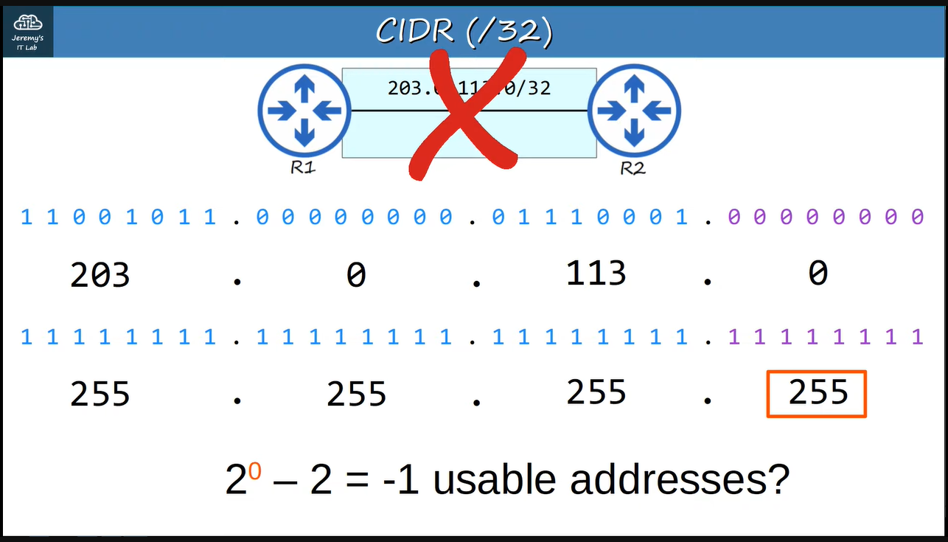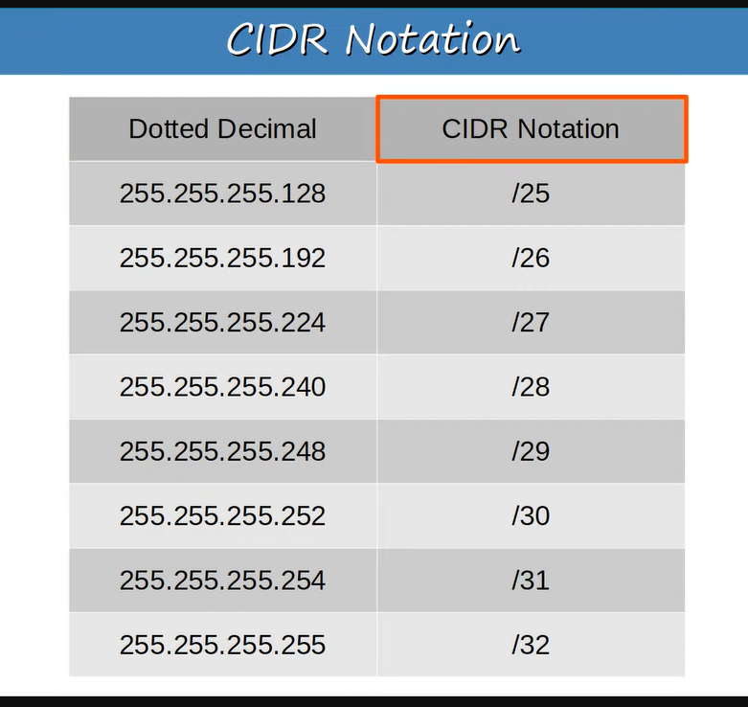

**Another example of subnetting ↓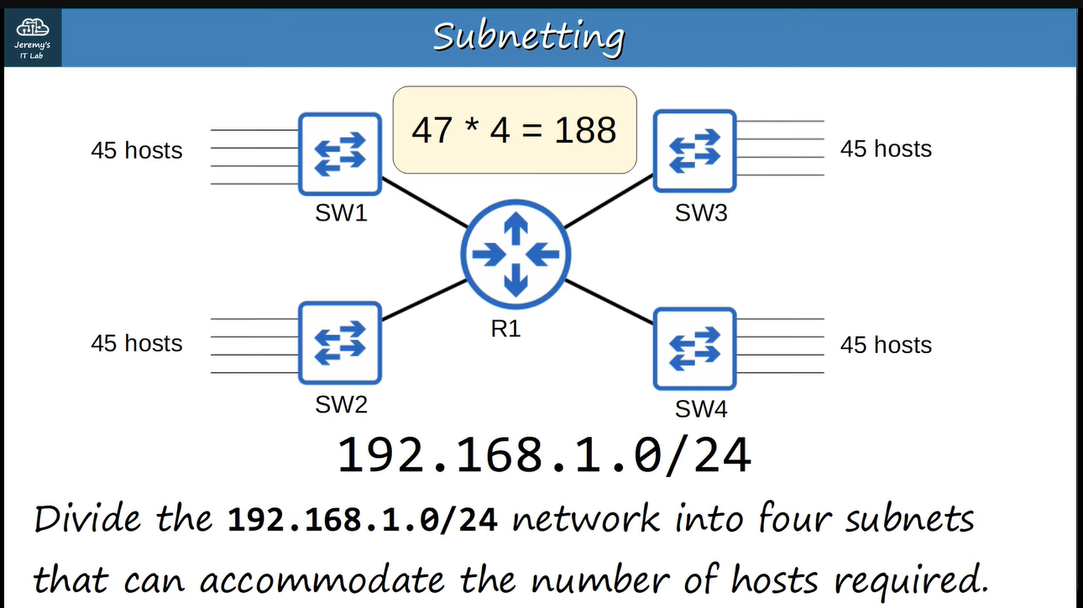The network 192.168.1.0/24 has 256 host addresses, we have to divide this network into 4 subnets where each has 45 hosts and network & broadcast addresses, i.e., 2 addresses so each subnet has 47 addresses and 🡪 47 * 4 = 188. Therefore, we need 188 addresses instead of 256 addresses, so, we have to find that subnet-mask using which our need is fulfilled ↓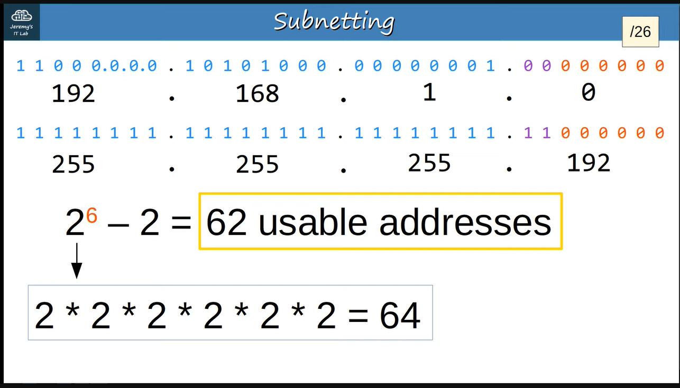/27 has less than our need, so, we have to use /26**

**Let us distribute the addresses between those 4 subnets ↓**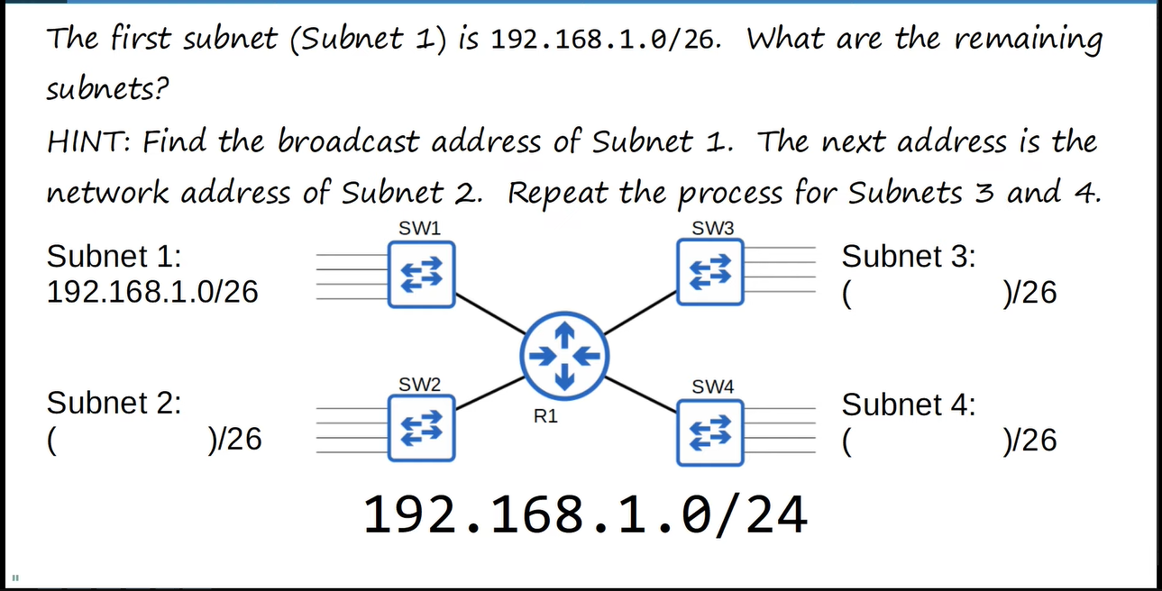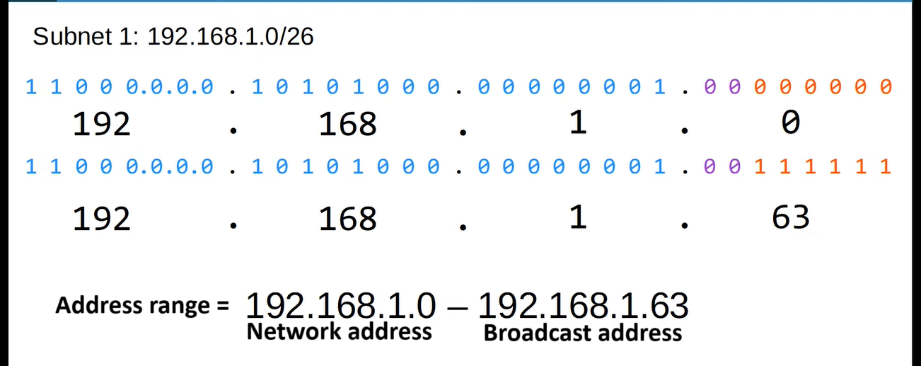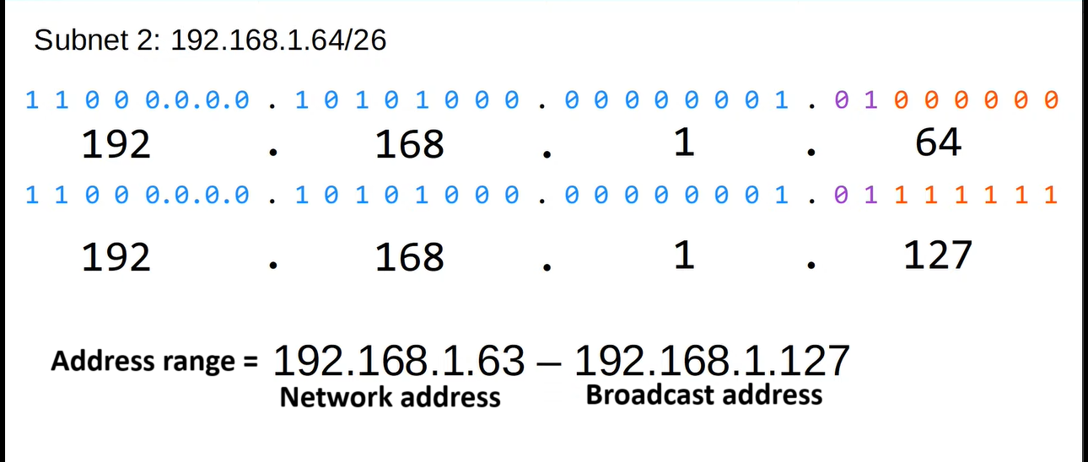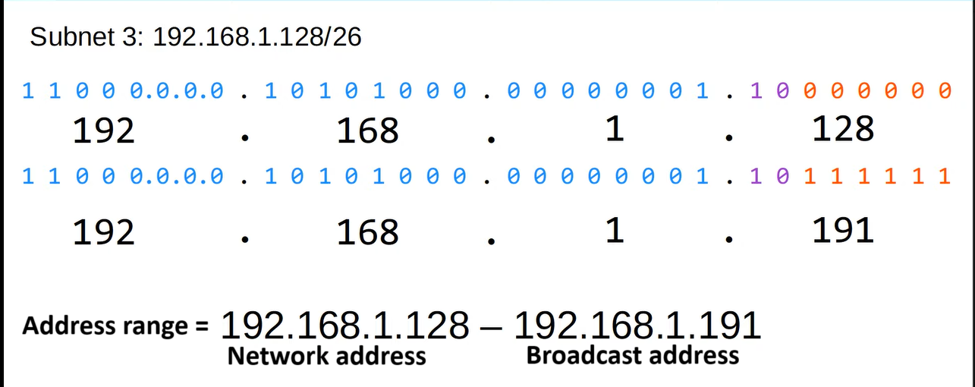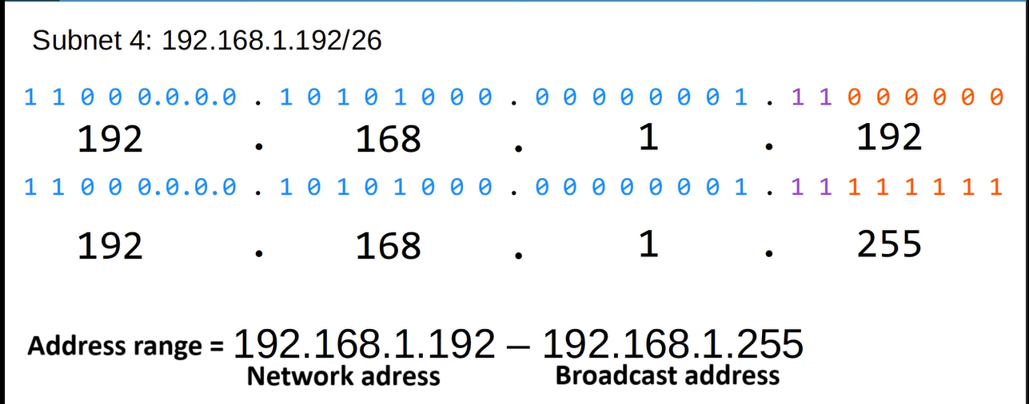

**Now we will see subnetting-trick to find the first address and the last address of each subnet ↓**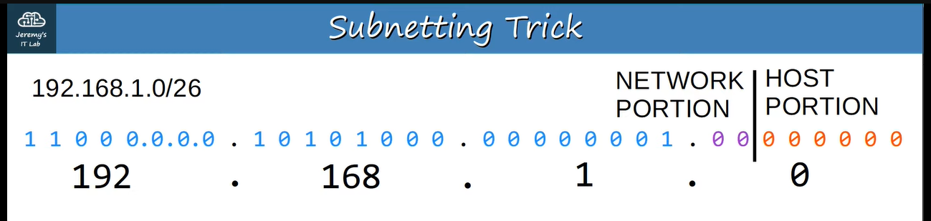

**This is network address or first address of subnet-1, after adding 64 (last bit of the network portion ) we will get the network address or first address of subnet-2, and after adding again 64 we will get network address or first address of subnet-3 and similarly we can find network address or first address of subnet-4 ↓**

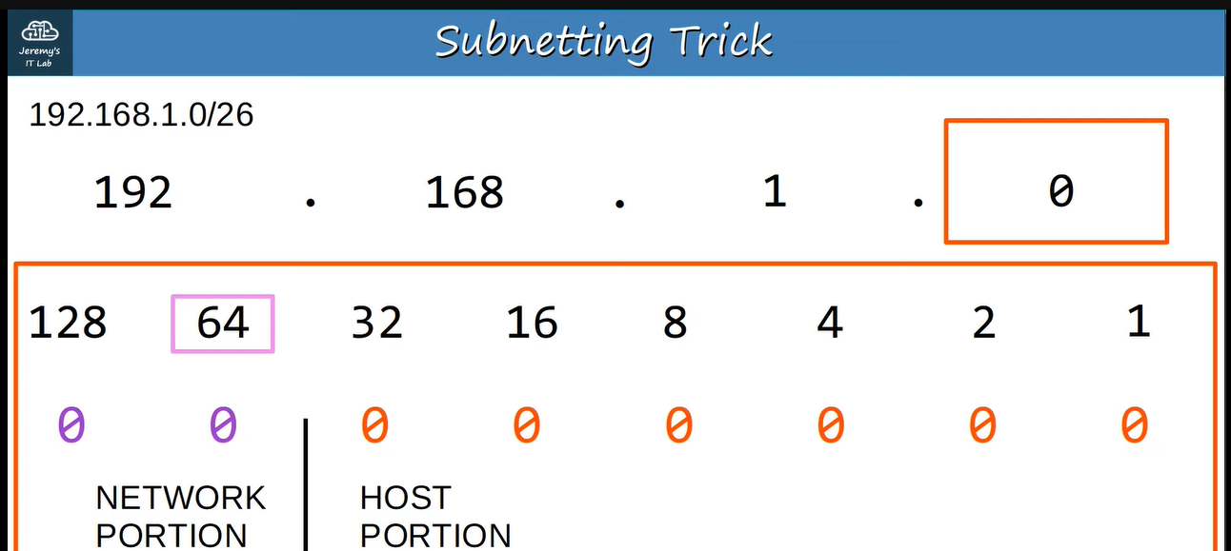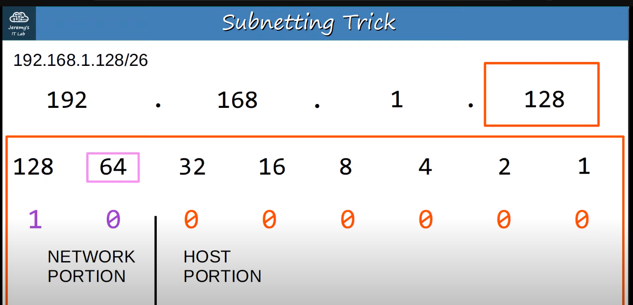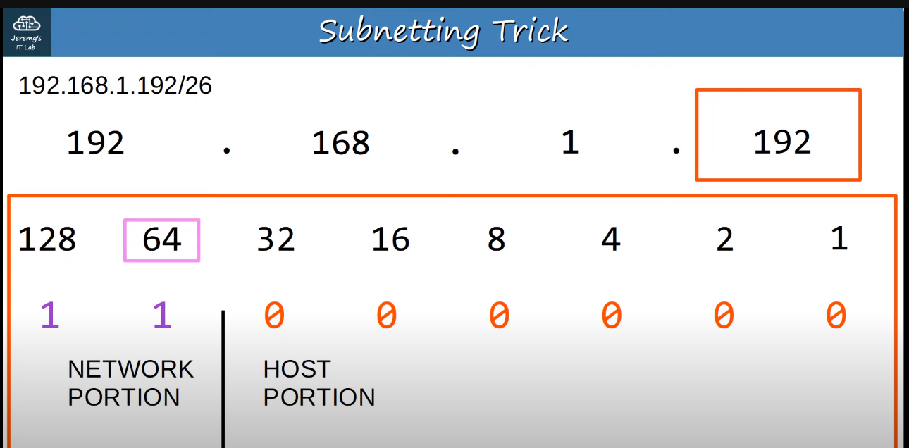

**Another example of subnetting ↓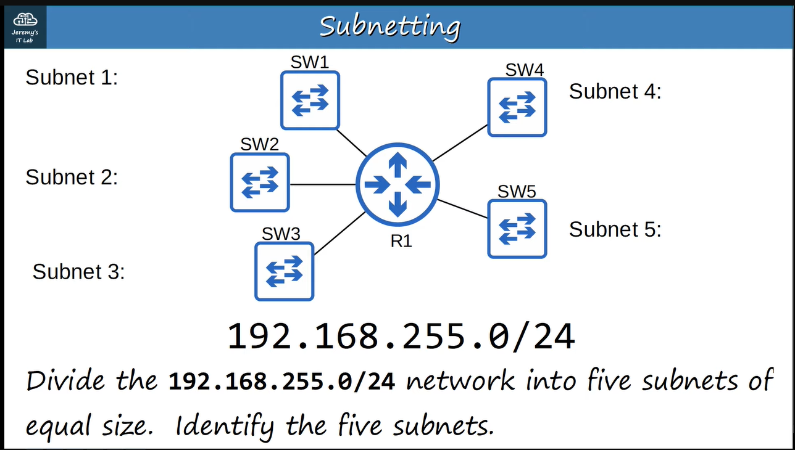 in this case, the no. of hosts in each subnet hasn’t been specified, so let’s make five subnet that are as large as they can be. To solve it we have find that how many bits we have to borrow from the host portion, i.e., which subnet-mask we have to choose.**

**First we will see a formula ↓**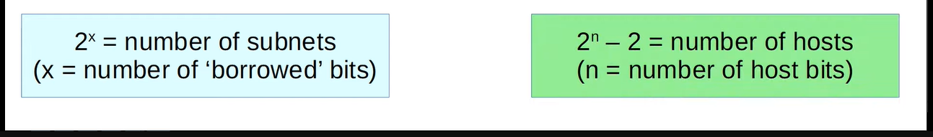

**Therefore, we have to borrow 3 bits from host portion, however, it will give 8 subnets but we have no choice, because, we need 5 subnets, in other words, we will have to choose /27 subnet-mask ↓**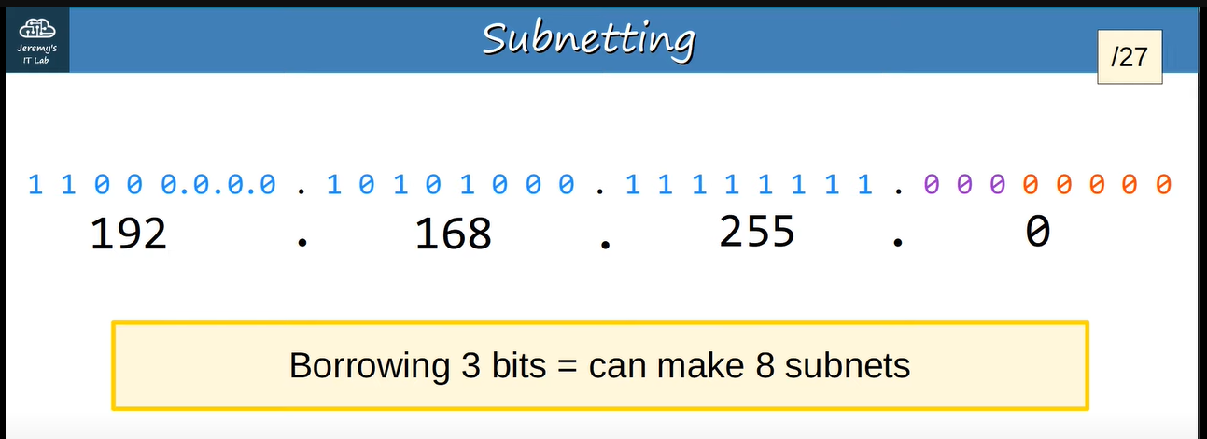

**Now we will distribute the addresses between those 5 subnets using subnetting-trick that we have seen previously, so, ↓**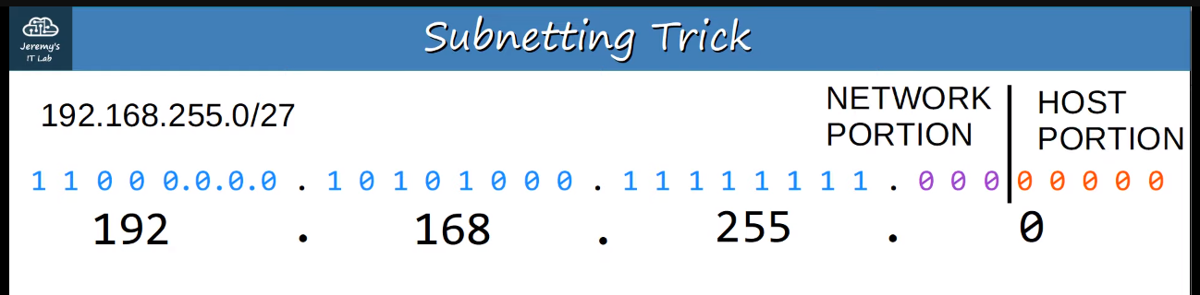

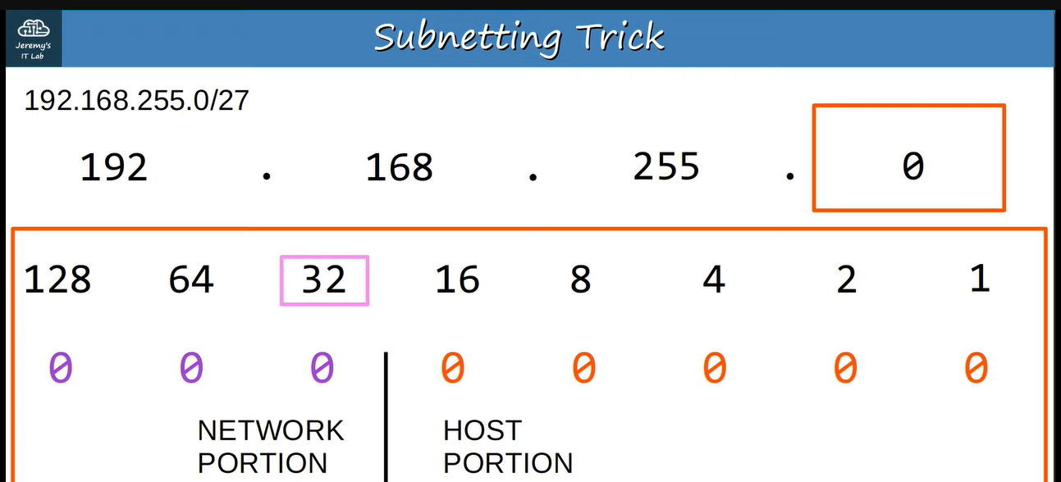**192.168.255.0 is the network address or first address of subnet-1, after adding 32 (last bit of the network portion ) we will get the network address or first address of subnet-2, and after adding again 32 we will get network address or first address of subnet-3 and similarly we can find network address or first address of subnet-4 ↓**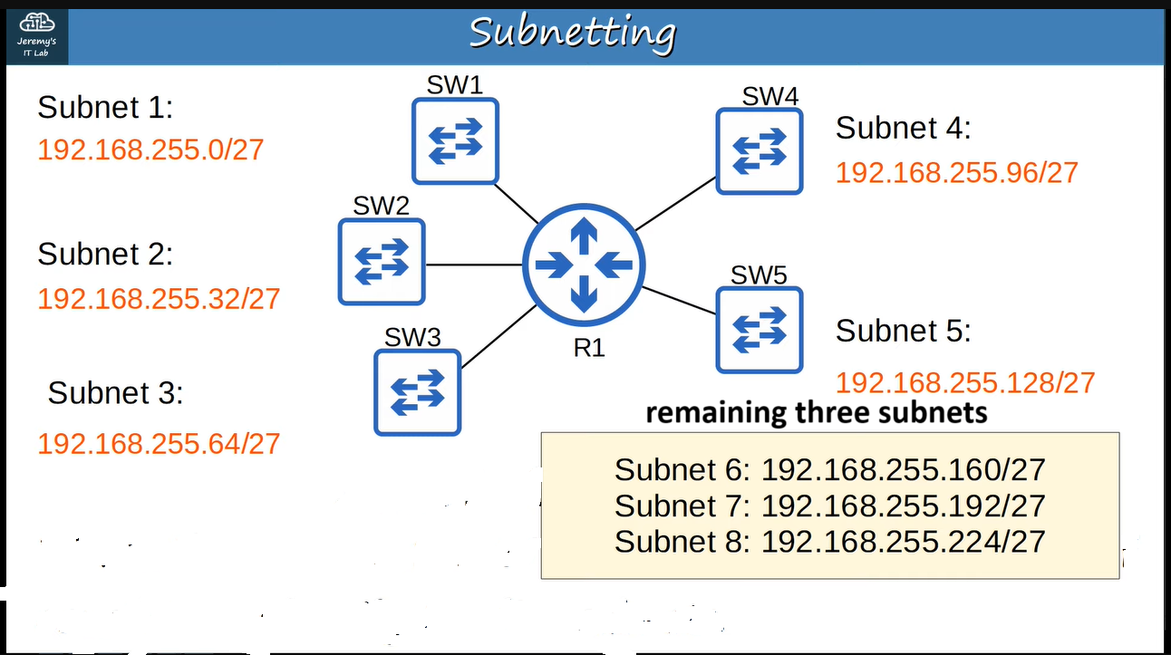

**How to find that what subnet does a host belong to? ↓**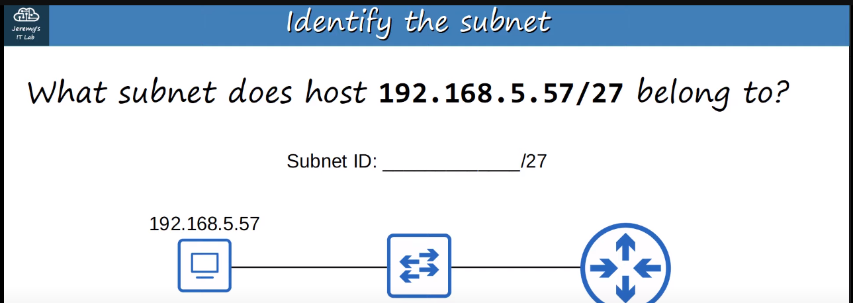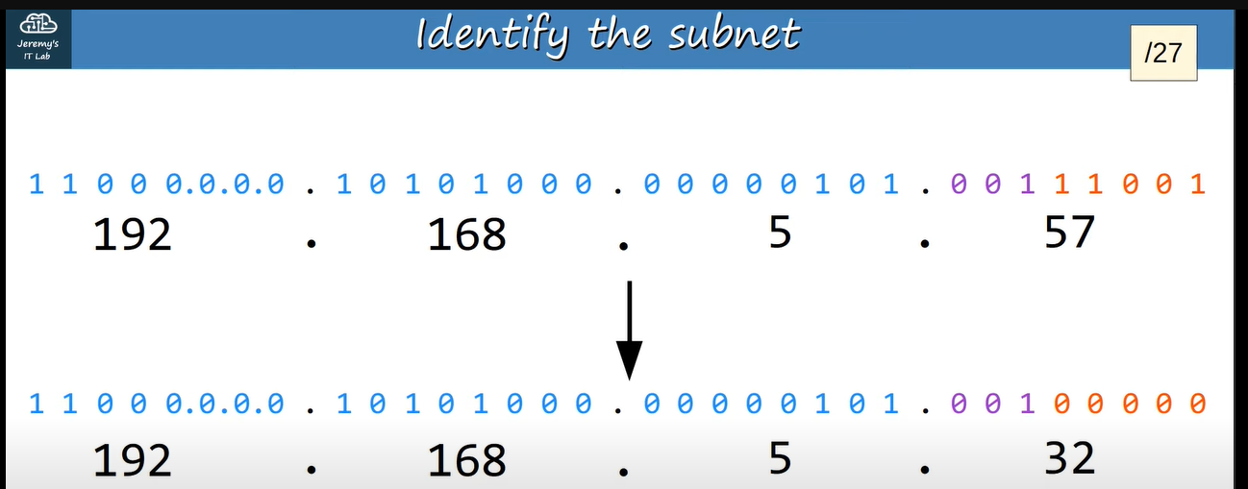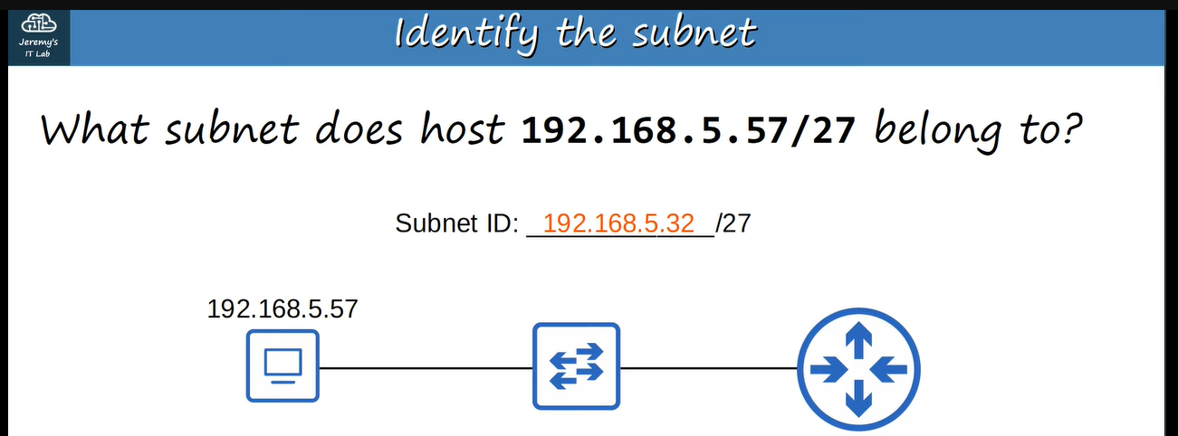

**Similarly ↓**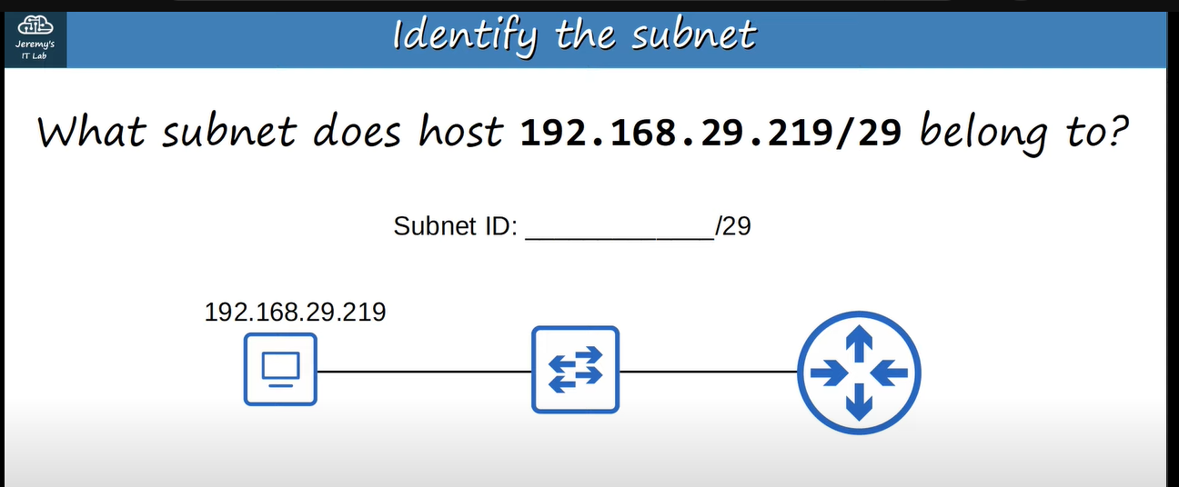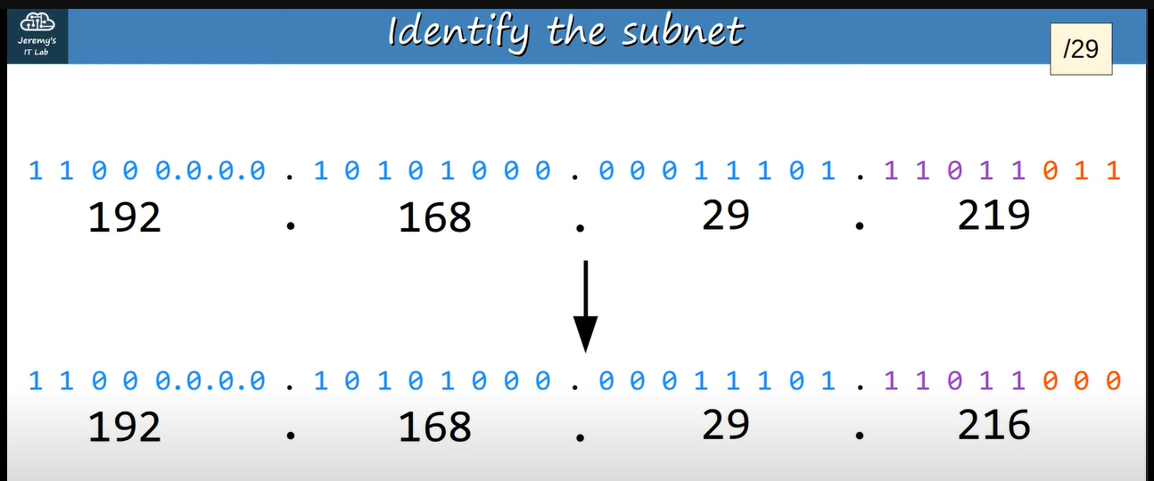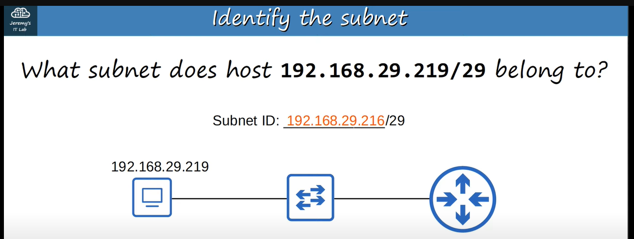

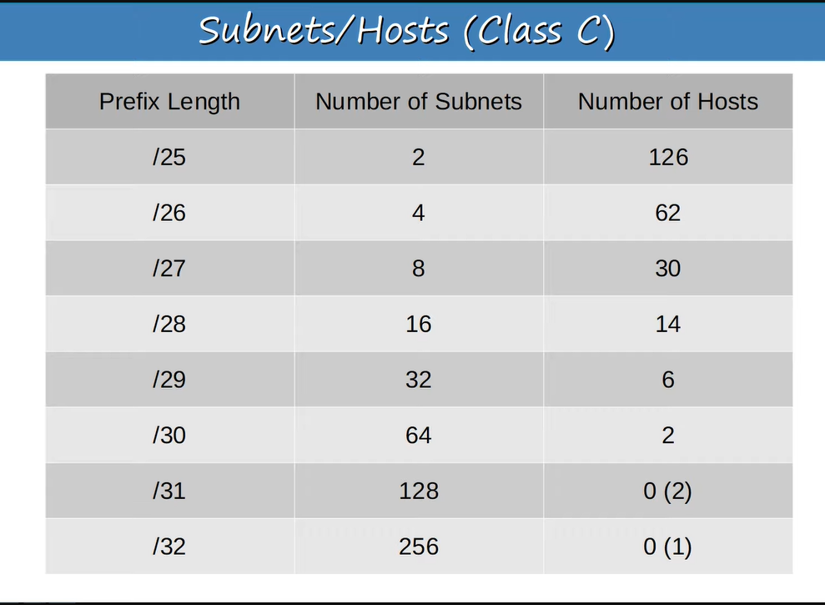

**Until now we were seeing subnetting in class C, now we will see subnetting in class B**

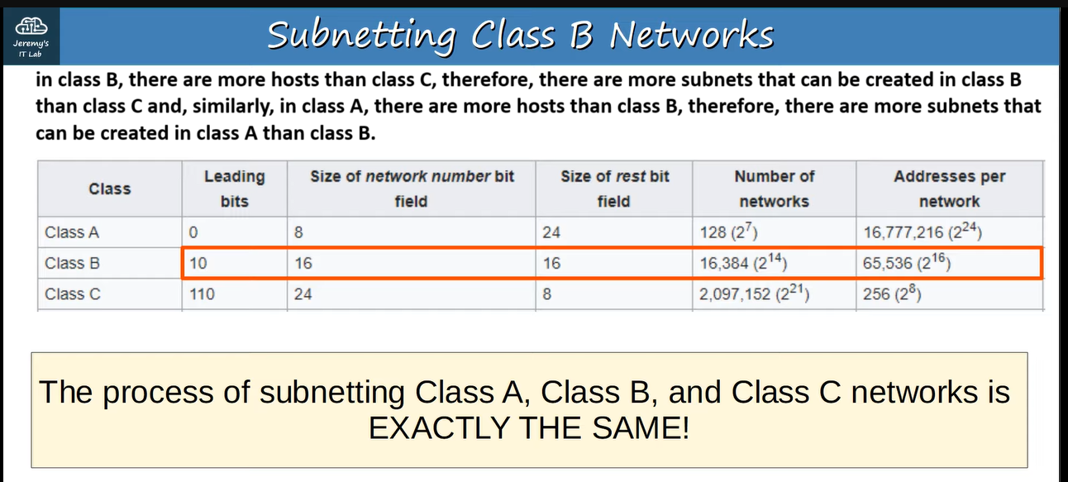

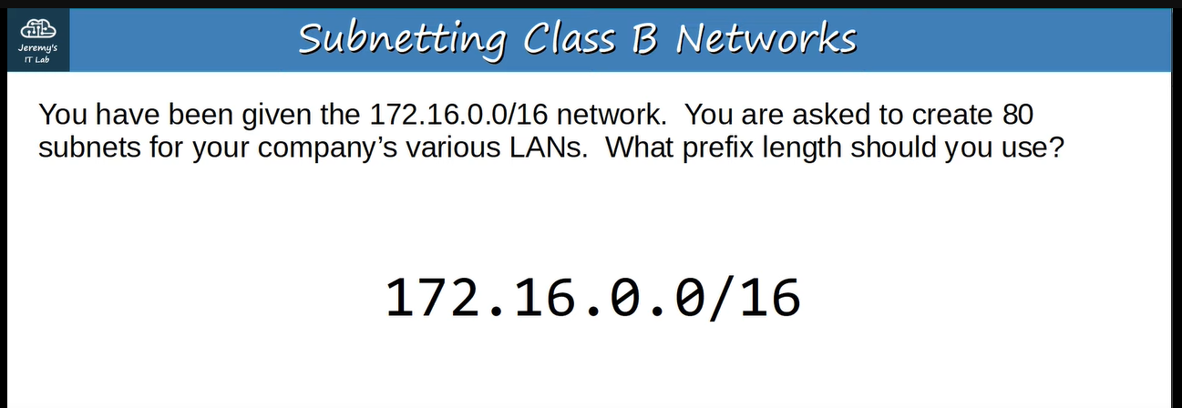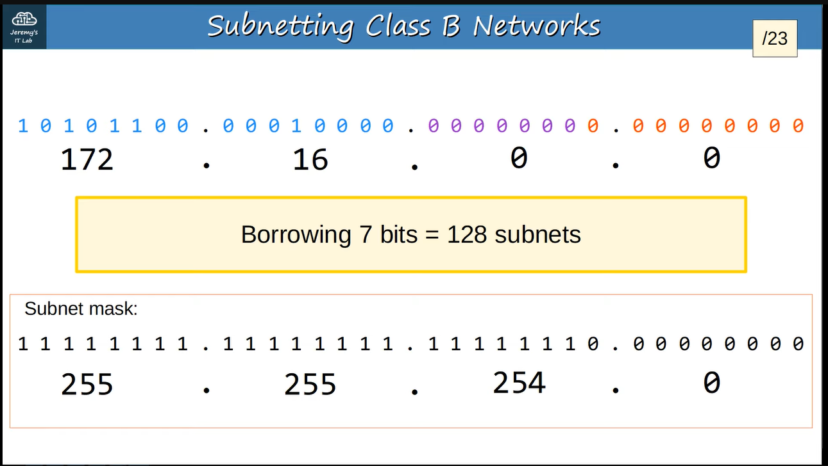**We can’t show all 80 subnets but you can find subnets from the following series of subnets** 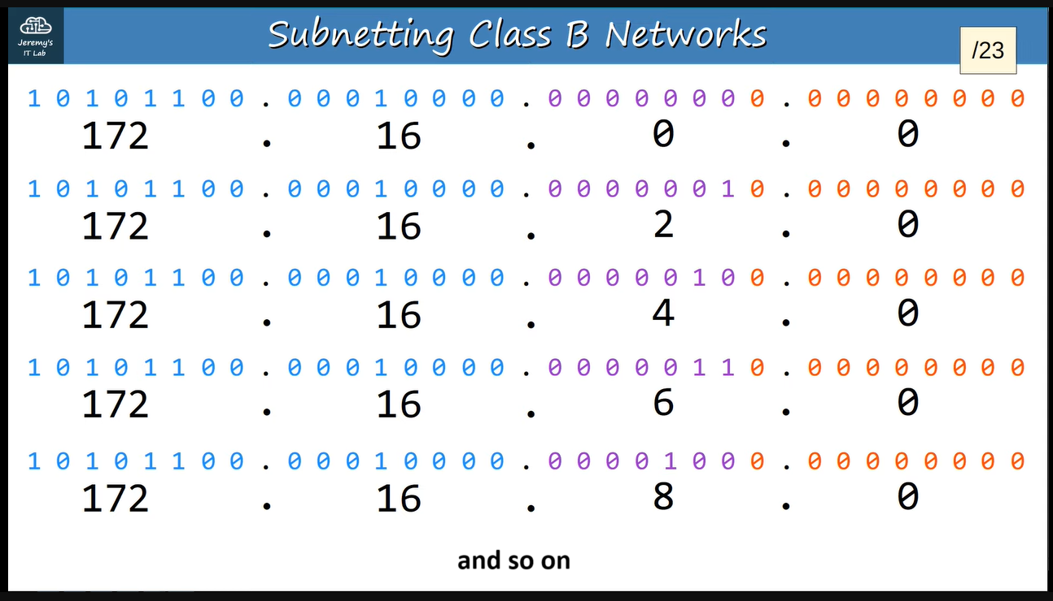

**Another example ↓**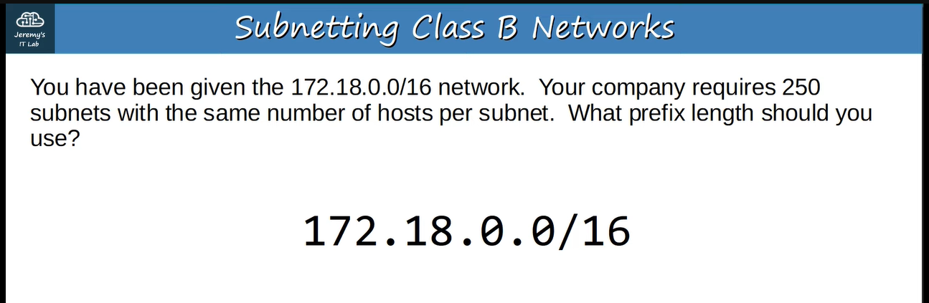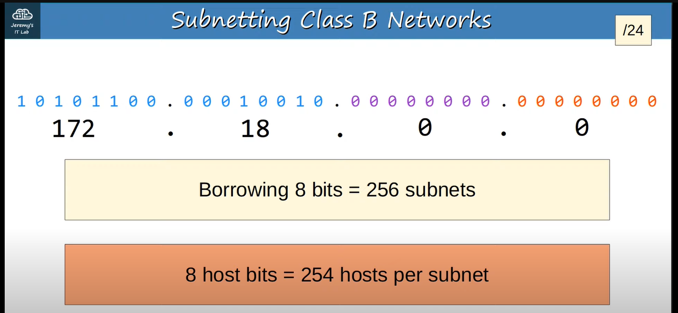

**Another example ↓**